Viewer, Beware! You’re In For A Scare!
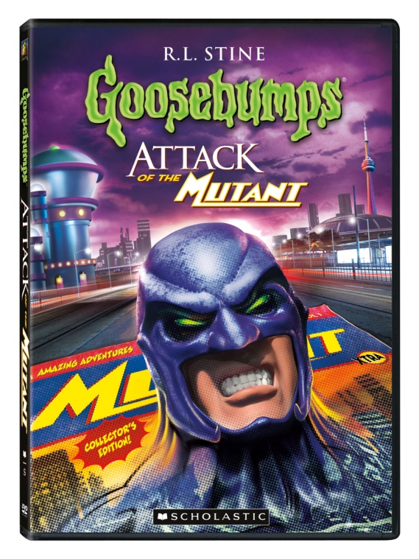
Try Not To Scream As Two Thrilling All-New Goosebumps® Adventures Attack of the Mutant & Ghost Beach –
Arrive On DVD September 13
Los Angeles, CA (August 2, 2011) – Get goose bumps and keep the light on to ward off the ghosts, goblins, mutants and madness as Goosebumps®: Attack of the Mutant and Goosebumps®: Ghost Beach scare their way onto DVD September 13, 2011 from Twentieth Century Fox Home Entertainment.

With over 300 million books sold, R.L. Stine’s wildly successful children’s stories (www.scholastic.com/goosebumps ) come to life with two all-new terrifying tales. First, Attack of the Mutant includes “Attack of the Mutant Parts 1 & 2” and follows Skipper Matthews and his awesome comic book collection. Skipper’s favorite is The Masked Mutant, the story of an evil, power-mad super villain who is out to gain control of the universe. One day, while lost in a strange part of town, Skipper discovers a building that mysteriously resembles the Mutant’s secret headquarters... a building that magically disappears. Has Skipper read one too many comic books? Or does The Masked Mutant really exist? The DVD also features “Phantom of

the Auditorium™,” a frightening story about a young actress who is thrilled after winning the lead in the school play... until the nightmares begin as there is talk of a real phantom who has haunted the auditorium for years.

Next, Ghost Beach includes “The Barking Ghost” and follows Cooper Holmes, a young man who is scared of just about everything. His father says he’s the only kid to scare himself on Halloween! But as he moves into a new house, this time Cooper is not just scared of his own shadow. In “Be Careful What You Wish For,” class klutz Samantha Byrd is the laughingstock of the girls’ basketball team. But now, Samantha has found someone who will grant her three wishes. Too bad she wasn’t more careful as now Sam’s wishes are turning her life into a living nightmare! Lastly, “Ghost Beach” focuses on Jerry, who is thrilled by the prospect of exploring the dark, eerie old cave he discovered down by the beach. When he hears the story of a 300-year-old ghost living inside, Jerry must decide if he will believe the legend or dismiss it as a silly made-up tale.

Watch these latest spooky Goosebumps® stories on September 13… if you dare!

About Twentieth Century Fox Home Entertainment
Twentieth Century Fox Home Entertainment, LLC (TCFHE) is a recognized global industry leader and a subsidiary of Twentieth Century Fox Film Corporation, a News Corporation company. Representing 75 years of innovative and award-winning filmmaking from Twentieth Century Fox, TCFHE is the worldwide marketing, sales and distribution company for all Fox film and television programming, acquisitions and original productions on DVD, Blu-ray Disc Digital Copy, Video On Demand and Digital Download. The company also releases all products globally for MGM Home Entertainment. Each year TCFHE introduces hundreds of new and newly enhanced products, which it services to retail outlets from mass merchants and warehouse clubs to specialty stores and e-commerce throughout the world.
Scholastic Corporation (NASDAQ: SCHL) is the world’s largest publisher and distributor of children’s books and a leader in educational technology and children’s media. Scholastic creates quality educational and entertaining materials and products for use in school and at home, including children's books, magazines, technology-based products, teacher materials, television programming, film, videos and toys. The Company distributes its products and services through a variety of channels, including proprietary school-based book clubs and school-based book fairs, retail stores, schools, libraries, television networks and the Company’s Internet Site,www.scholastic.com.

Press materials available at www.foxpressroom.com
For screeners, contact: FoxMGMRequests@hillandknowlton.com
Follow Twentieth Century Fox Home Entertainment on Twitter @FoxHomeEnt

Media inquiries:
Fox: Jennifer Lang, 310.369.3980, jennifer.lang@fox.com
US: Conor Sellers, 310.633.9453, conor.sellers@hillandknowlton.com
Online: Claire Richland, fox@thinkjam.com
Canada: Bernice Couto, 416.486.7219; bernice.couto@gcicanada.com

Goosebumps: Attack of the Mutant & Ghost Beach

Street Date: September 13, 2011
Pre-book Date: August 3, 2011
Screen Format: 1.33:1
Audio: English Stereo
Subtitles: English, Spanish
Total Run Time: 66 minutes (each DVD)
MPAA Rating: NR
Closed Captioned: Yes

